This template must be used to answer the case study.
(Please type your answers within the box underneath each question)

Student name (LAST NAME first name):
Student number:
Campus:
Tutorial session (time and room no.):
Tutor’s name:
- Rationale for giving Mary a tetanus booster (Total: 10 marks)
  - What is the organism that causes tetanus and why is it of concern in this situation?
(5 marks)
Tetanus fact sheet NSW HEALTH
Tetanus is a bacterial infection caused by Clostriduim tetani. This bacterium is responsible for releasing toxins, which lead to the onset of the infection. The disease causes muscle spasms in the neck and jaw (lockjaw) and in severe cases it leads to death. It is of concern because 1 in every 10 people infected by the disease die. Tetanus is non-contagious and can affect people of all ages. However, babies and older people are at a higher risk of dying from the disease (Australian Government, Department of Health, 2021). Because Mary has a deep cut, which she got while working at the farm, and it is unclear whether she has had a tetanus vaccination, it is necessary for her to receive medication.

  - Discuss the rationale for giving Mary the tetanus booster. (5 marks)
https://immunisationhandbook.health.gov.au
Australian immunisation handbook

The rationale for giving Mary a tetanus booster is that she is an older woman (50 years) and at the risk of dying from the infection. According to the guidelines in the Australian Immunization Handbook, it is recommended that Australians above 50 years of age to get a tetanus toxoid booster. This booster is recommended to those who have not received a vaccination in the last 10 years. A booster soon after the cut is necessary because there have been cases where it fails to work optimally. Exposing herself in the soil while working in the farm, Mary exposes herself to Clostridium tetani, thus a higher risk of contracting the disease.

- Physiological basis of the three wound observations (Total: 20 marks)
  - For each of the three wound observations indicate, and provide a rationale, as to whether it is a sign or a symptom. (2 marks)
When the injury occurs, inflammation response sets in. The body prepares itself to fight the foreign bacteria and at the same time repair the damaged skin tissue. The body achieves this through homeostasis, where it tries to self-regulate to maintain stability by adjusting to the changing external environment. There was increases tissue fluid, which caused swelling and pain. The resulting pain is an indication that bacterial toxins have been released. These signs are an indication that Mary has been exposed to the bacteria (p.816).

  - Name and discuss the physiological basis of the first observation. (6 marks)
The first observation is that the wound edges are red and hot to touch. This is an indication that toxins, that lead to inflammation have been released. Chemicals that cause inflammation can include histamines, kinins, prostaglandins, and complement components. These chemicals are responsible for increases permeability and dilation of arteries. Increased dilation and permeability increase blood flow to the area, increases the flow of lymphocytes, monocytes, and neutrophils. Increased temperature in the wound can be linked to increased metabolism of the cells (pg.817).

  - Name and discuss the physiological basis of the second observation. (6 marks)
The second observation is swelling of the surrounding tissue. This observation can be linked to increased leakage of fluids from capillaries, which form an exudate. The fluid fills spaces between tissues and cells, causing local swelling (edema) (p.818). Increased swelling presses the surrounding nerves, resulting to increased localized pain.

  - Name and discuss the physiological basis of the third observation. (6 marks)
The third observation was the presence of a purulent and odorous discharge. This observation is an indication that the wound has been infected. This is consistent with the presence of a fever, which can prompt Mary to take antibiotics for treatment of the infection. Exposing the wound to soil in the farm is the main cause why it was infected with the bacteria. Tissues in the open would provide an optimal environment for the microorganisms to thrive. To get rid of the bacteria, the body responds by increasing the formation of exudate, through inflammation, swelling, and increased pain (p.817). A physician can take a sample of tissue culture from the wound to examine the presence of microorganisms and recommend the most effective antibiotic for the infection.

- Development and benefits of fever (Total:15 marks).
  - How did Mary’s fever develop? (9 marks)
Mary developed a fever as a result of inflammation. Fever is a systemic response to an infection (p.196). body temperature is controlled by the hypothalamus and is set at 37˚C. Raising this set point leads to the development of fever. In the case of Mary, the presence of exogeneous pyrogens released by microorganisms led to an increase of body temperature, exceeding the set point. The presence of exogeneous pyrogens triggered a febrile response in the hypothalamus, which sets a higher temperature level than the normal. An increase in production of heat in the body is followed by the body trying to regulate the temperature, which leads to the development of a fever (p.196).

  - Discuss two ways in which fever is beneficial. (6 marks)
Fever plays an important role because it helps in the reduction of an infection. Disease causing microorganisms operate optimally in a specific temperature. When this temperature is exceeded, the microorganisms are unable to multiply, thus controlling the infection (Queensland Government, 2020). Fever also increases the metabolic rate and activity of defence cells, which speeds up repair and recovery process (Chapter 9, p.197). Fever helps in the improvement of the immune system, enabling a patient respond better to treatment and have a higher probability of achieving full recovery.

- Possible sources of contamination and modes of transmission (Total: 20 marks)
  - Name one endogenous source of contamination and discuss the mode of transmission from the source to the new host. (10 marks)
An example of an endogenous source of contamination is Escherichia coli in the colon. This in an endogenous source of contamination because the source of the pathogen is inside the human body (p144). Displacing the pathogen from its habitat in the large intestines can lead to an infection of another part of the body. Escherichia coli is transferred from the colon to the bladder through stool. E. coli enters the urinary tract through stool and is most common in women than in men. This is because women have a shorter urinary tract than men and their urethra is close to the anus. Therefore, the bacteria have an easy access to the urinary tract, where they can get access to the bladder and lead to the development of urinary tract infection.

  - Name one exogenous source of contamination and discuss the mode of transmission from the source to the new host. (10 marks)
An example of an exogenous source of contamination is in a hospital environment. For example, when a person is admitted in the hospital with Ebola, the virus is introduced in the hospital environment, where there is a probability of spreading. Ebola virus can be transmitted through direct contact with the blood or body fluids from an infected person, and exposure to objects that have been contaminated with blood or fluids from an infected person. When a nurse is administering treatment, s/he can be exposed to the fluids, especially when they fail to wear personal protective equipment. The nurse can then transmit the virus to other patients, which can cause a ripple effect throughout the hospital.

- Appropriateness of Augmentin as the antibacterial agent prescribed to Mary (Total: 15 marks)
  - Given the colonizing organism was Staphylococcus aureus, discuss why Augmentin is an appropriate prescription? (6 marks)
Augmentin is the appropriate prescription because of its ability to treat different bacterial infections. Although Staphylococcus aureus was treated using penicillin in the past, the bacteria have become resistant to the antibiotic because of their ability to produce enzyme penicillinase. Augmentin is appropriate because it will minimize the possible attack sites, which are possessed by procaryotic cells (p.267). Also, it is a broad-spectrum antimicrobial agent, implying that it can get rid of other pathogens entering the body through the open wound.

  - Describe the added benefits that Augmentin provides, with reference to the role of the major ingredients in Augmentin. (9 marks)
One of the advantages is that it can be used to treat different infections. As a broad-spectrum antimicrobial agent, the drug can be used to cure bacterial infections in different areas, including respiratory tract infections, bacterial sinusitis, animal and human bites, skin infection, UTIs, and chronic pulmonary disease. Another benefit is that the drug can be used alone or can be combined with other medications. Augmentin is beneficial over other antibiotics because it contains clavulanate, which helps in the treatment of resistant bacterial infections. Clavulanate plays a major role by preventing bacteria from destroying amoxicillin, which gives the drug a higher chance of inhibiting bacterial multiplication (Australian Prescriber, 1998).

- Presentation (Total: 20 marks)
  - Referencing in-text and in reference list conforms to APA 7th ed. Referencing style.
  - Critique supported by relevant literature as prescribed.
  - Correct sentence structure, paragraph, grammatical construction, spelling, punctuation, and coherent presentation.

References
Australian Government, Department of Health. (2021). Tetanus. https://www.health.gov/au/health-topics/tetanus
Australian Prescriber. (1998). Amoxycillin/clavulanic acid, 21: 49-55. https://doi.org/10.18773/austprescr.1998.049
Australian Technical Advisory Group on Immunization (ATAGI) (2018). Australian Immunization Handbook, Australian Government Department of Health, Canberra. https://immunisationhandbook.health.gov.au
Gordon, B., Young, K. A., Wise, J. A., Johnson, E., Poe, B., Kruse, D. H., Korol, O., Johnson, J. E., Womble M., & DesSaix, P. (2013). Anatomy and Physiology. Houston, Texas. https://openstax.org/book/anatomy-and-physiology/pages/1-introduction
Queensland Government. (2020). Fever. https://conditions.health.qld/gov.au/HealthCondition/condition/8/12/317/fever

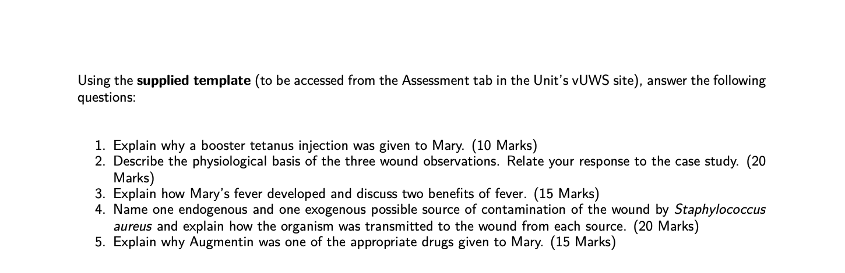
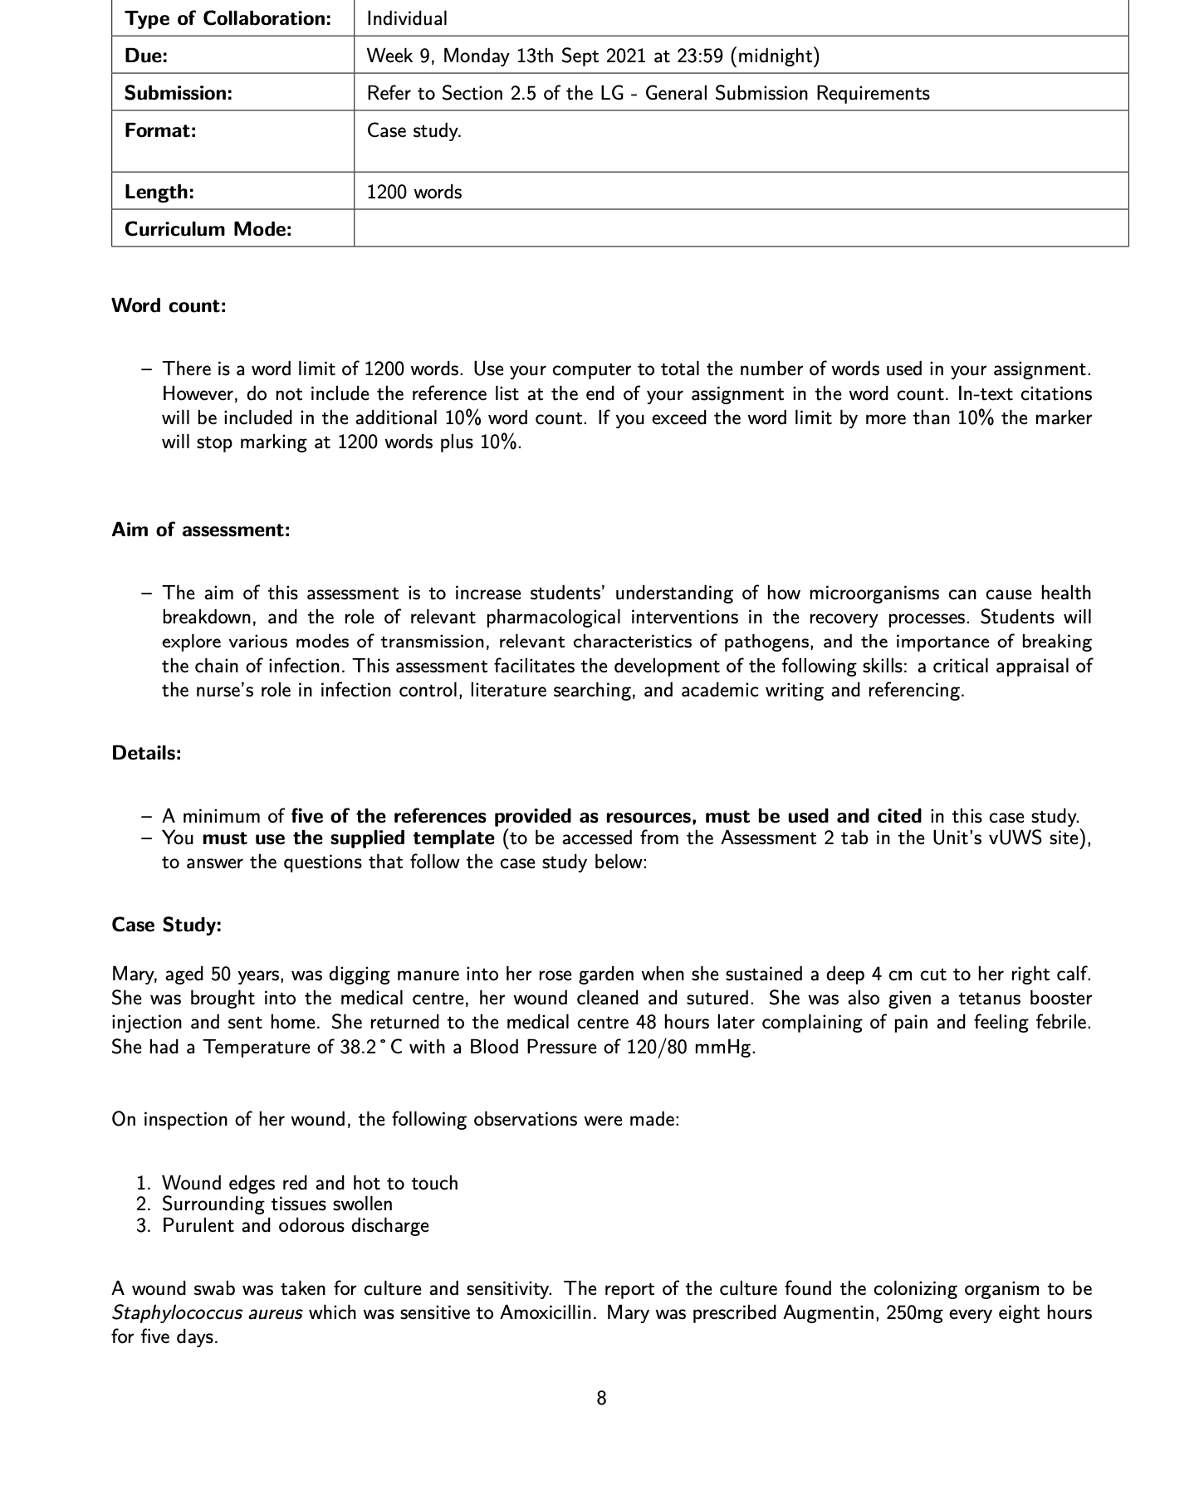
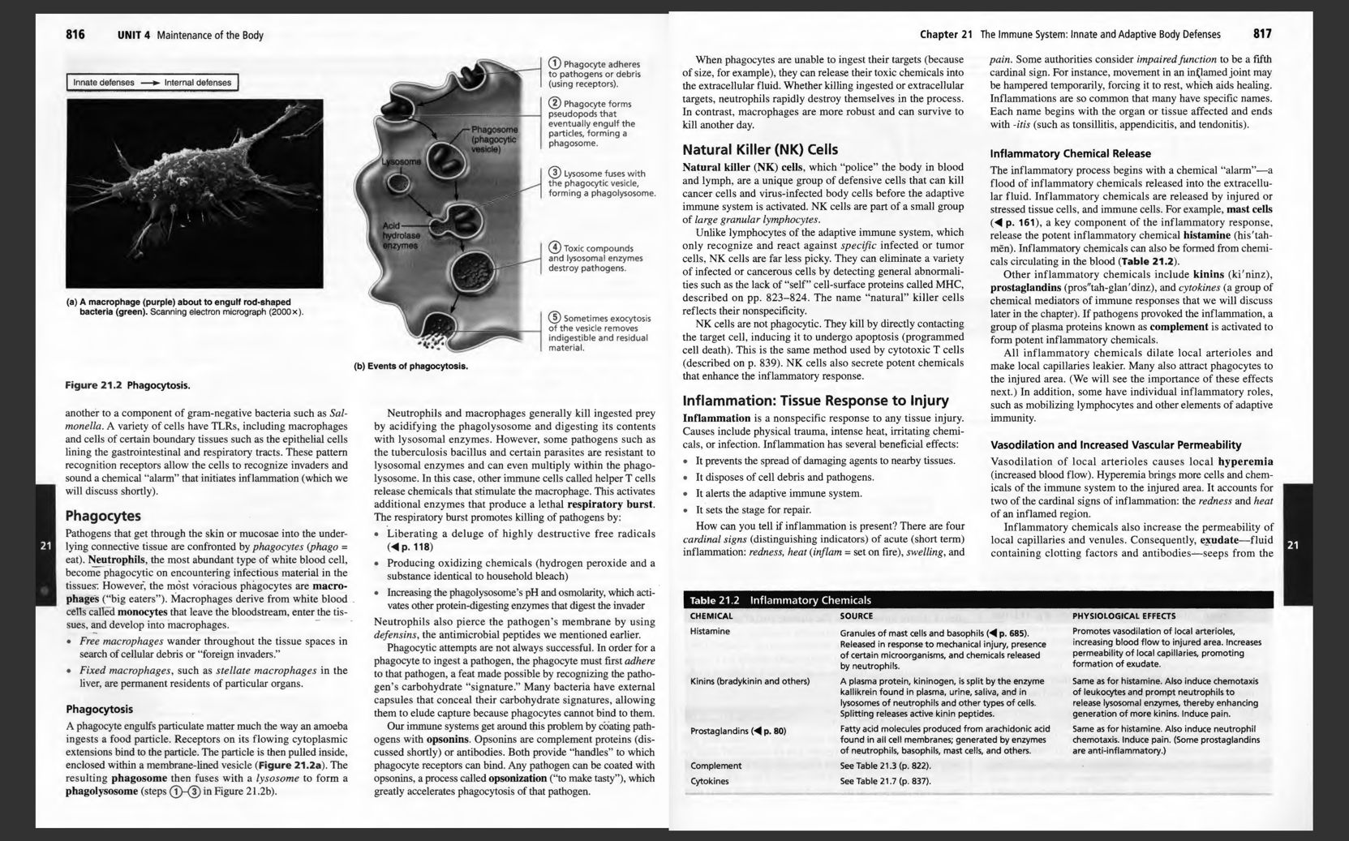
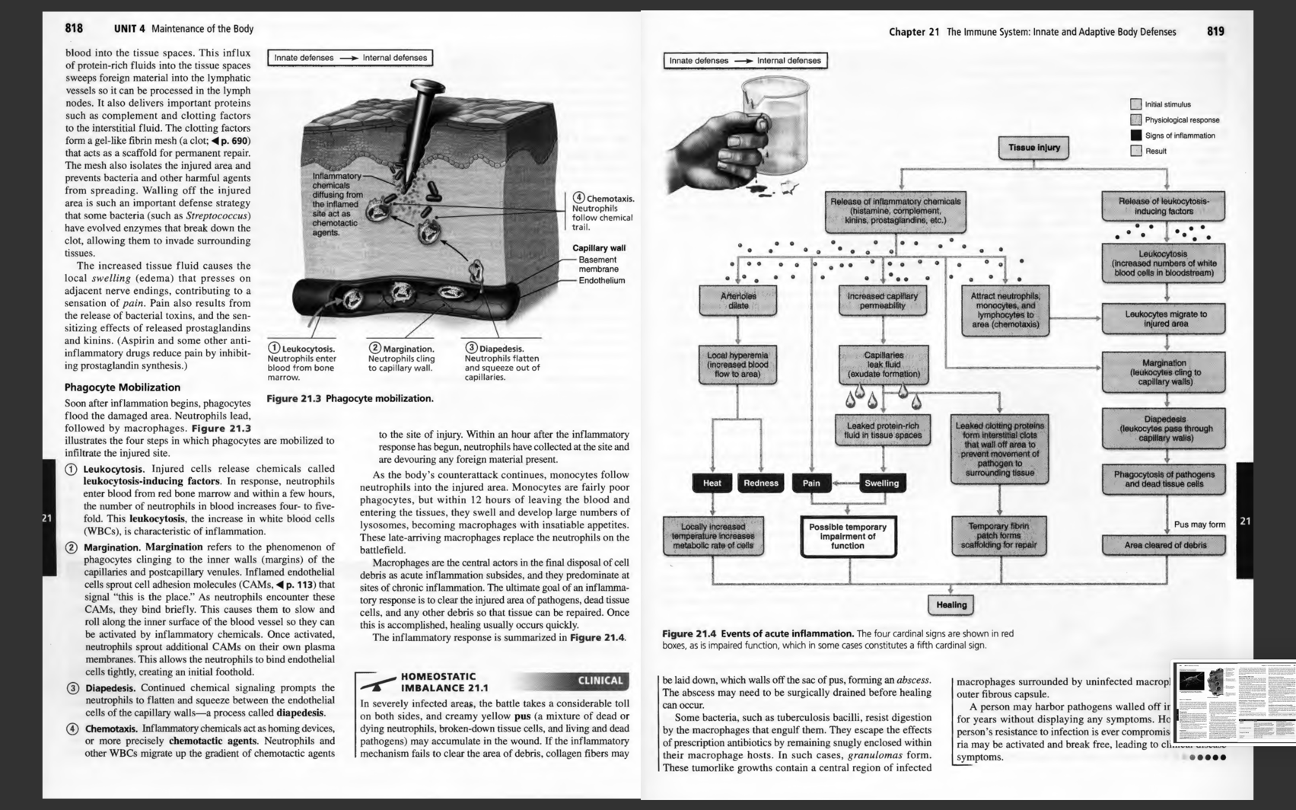
For question 2 and question 3
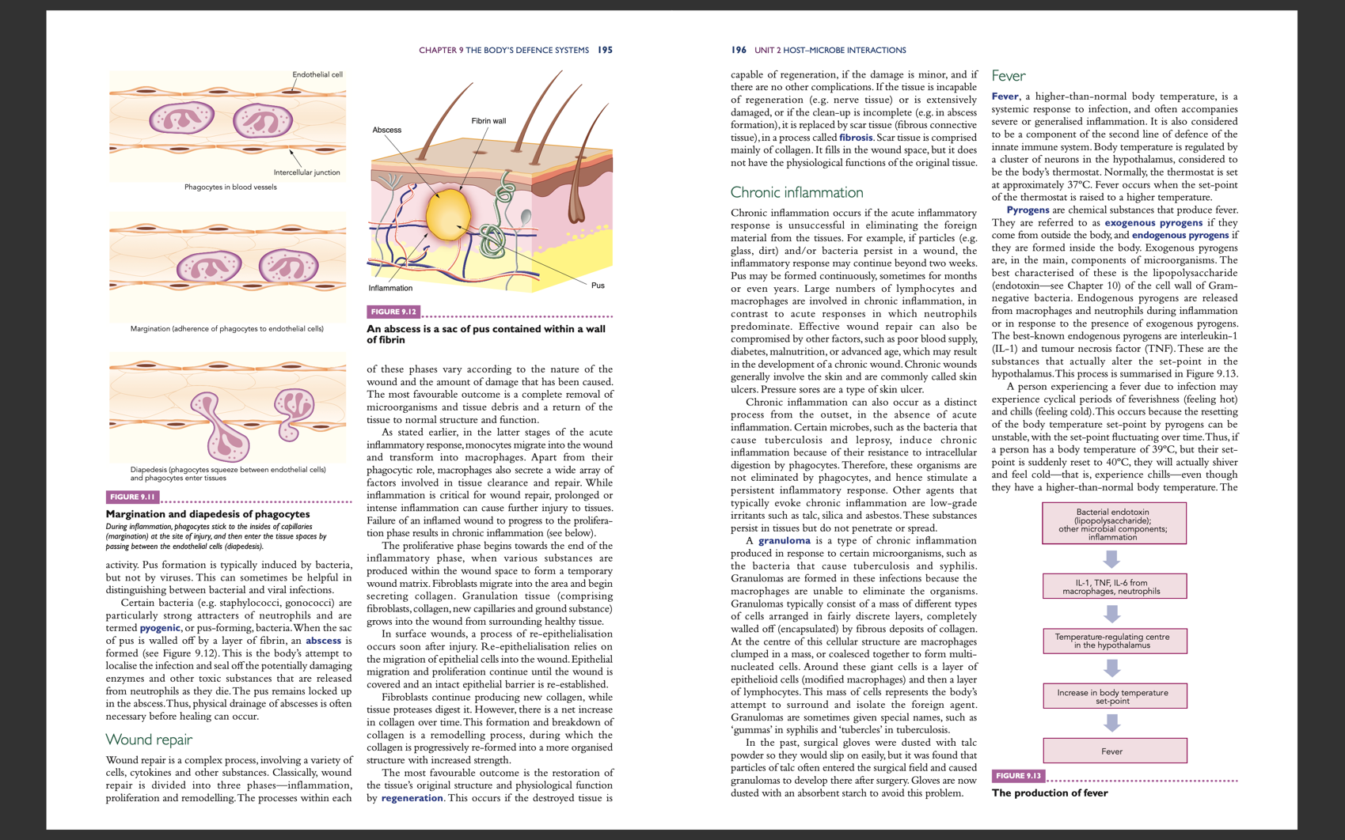
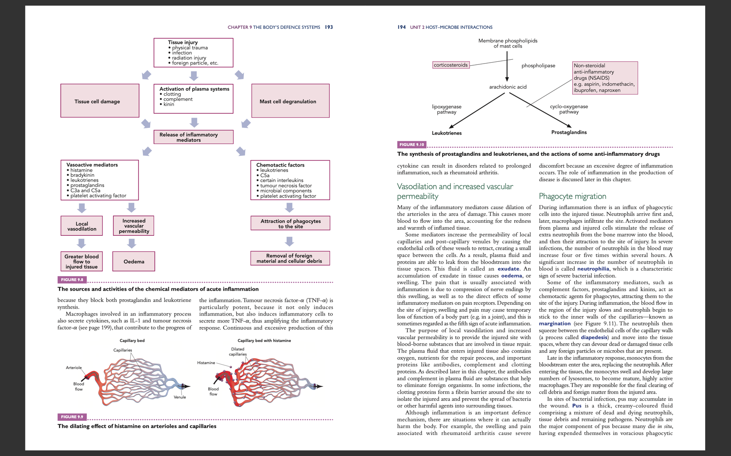
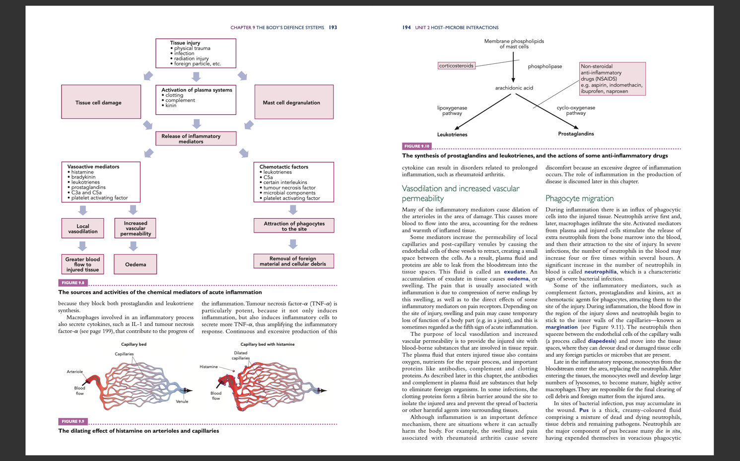
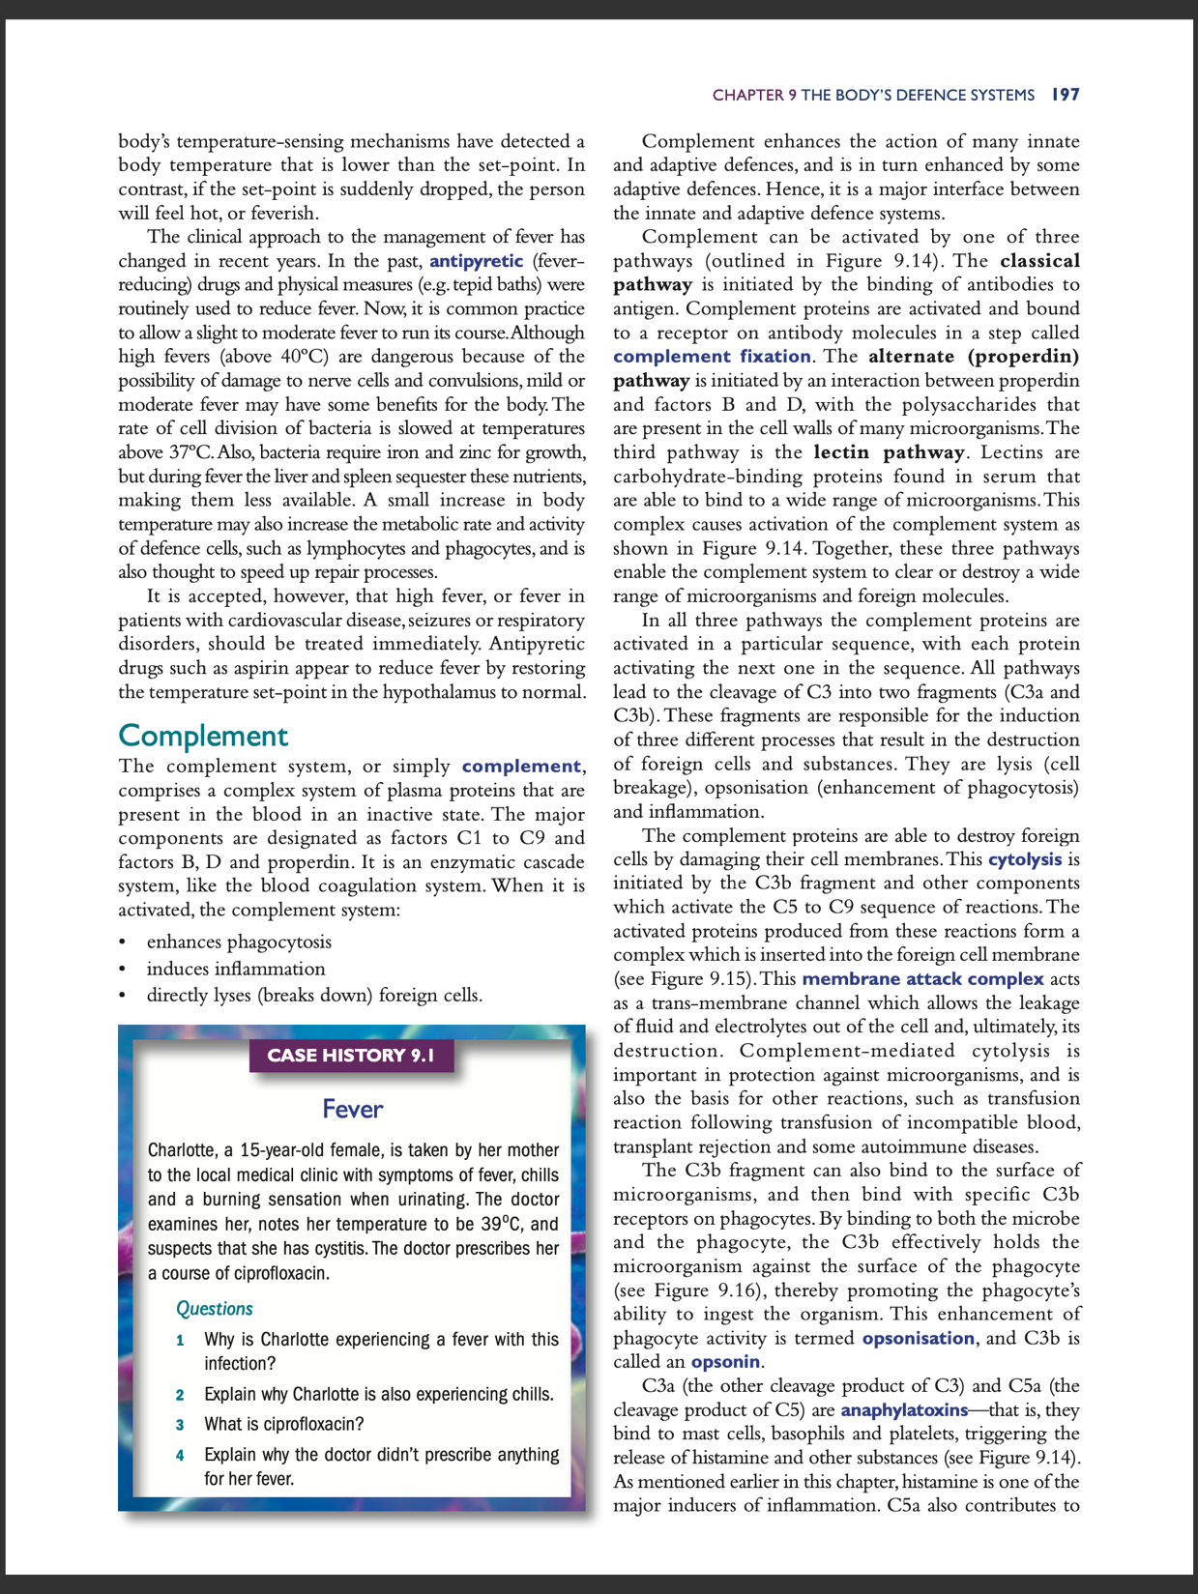

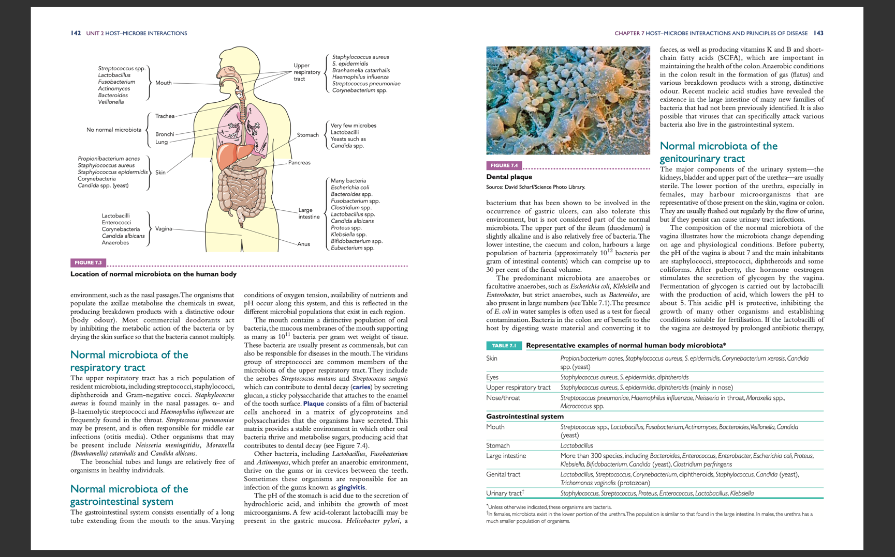
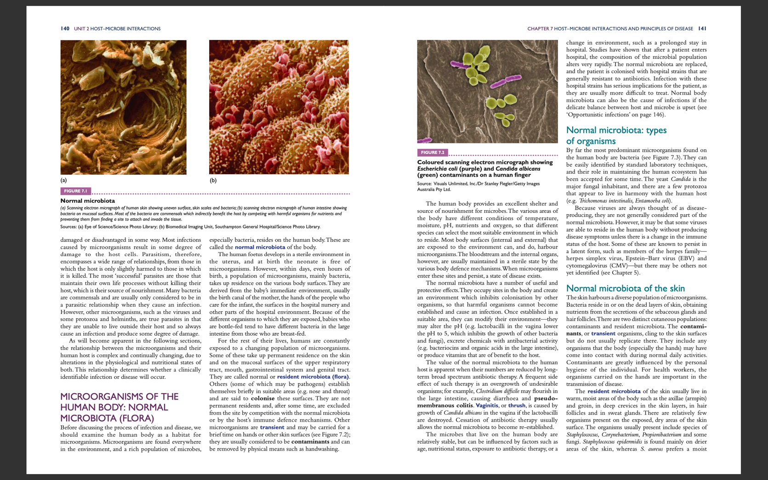
For question 4
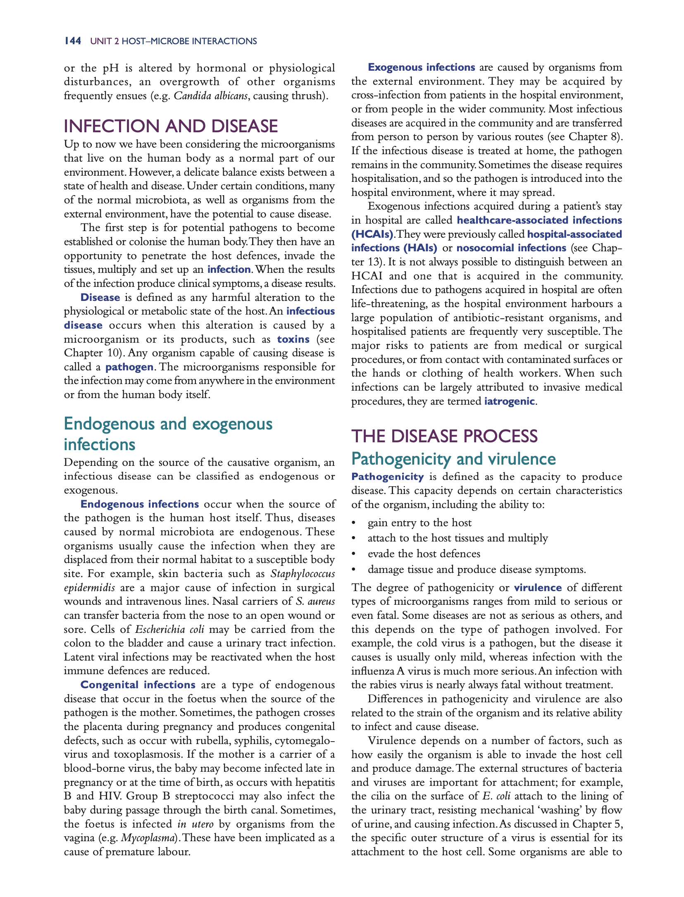

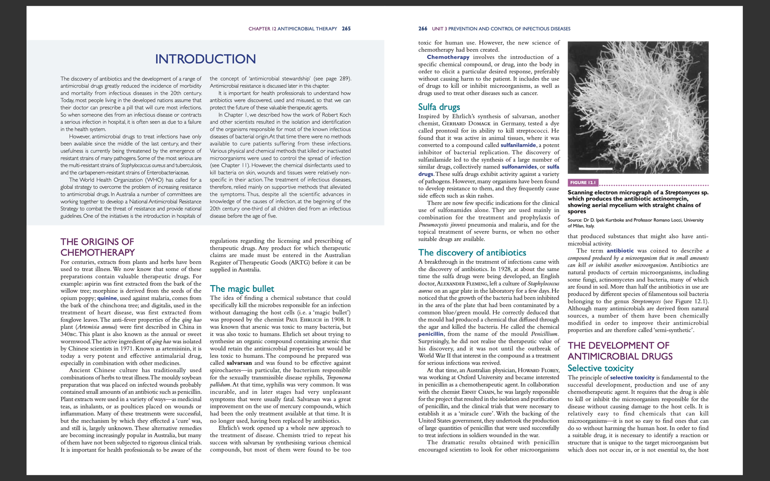
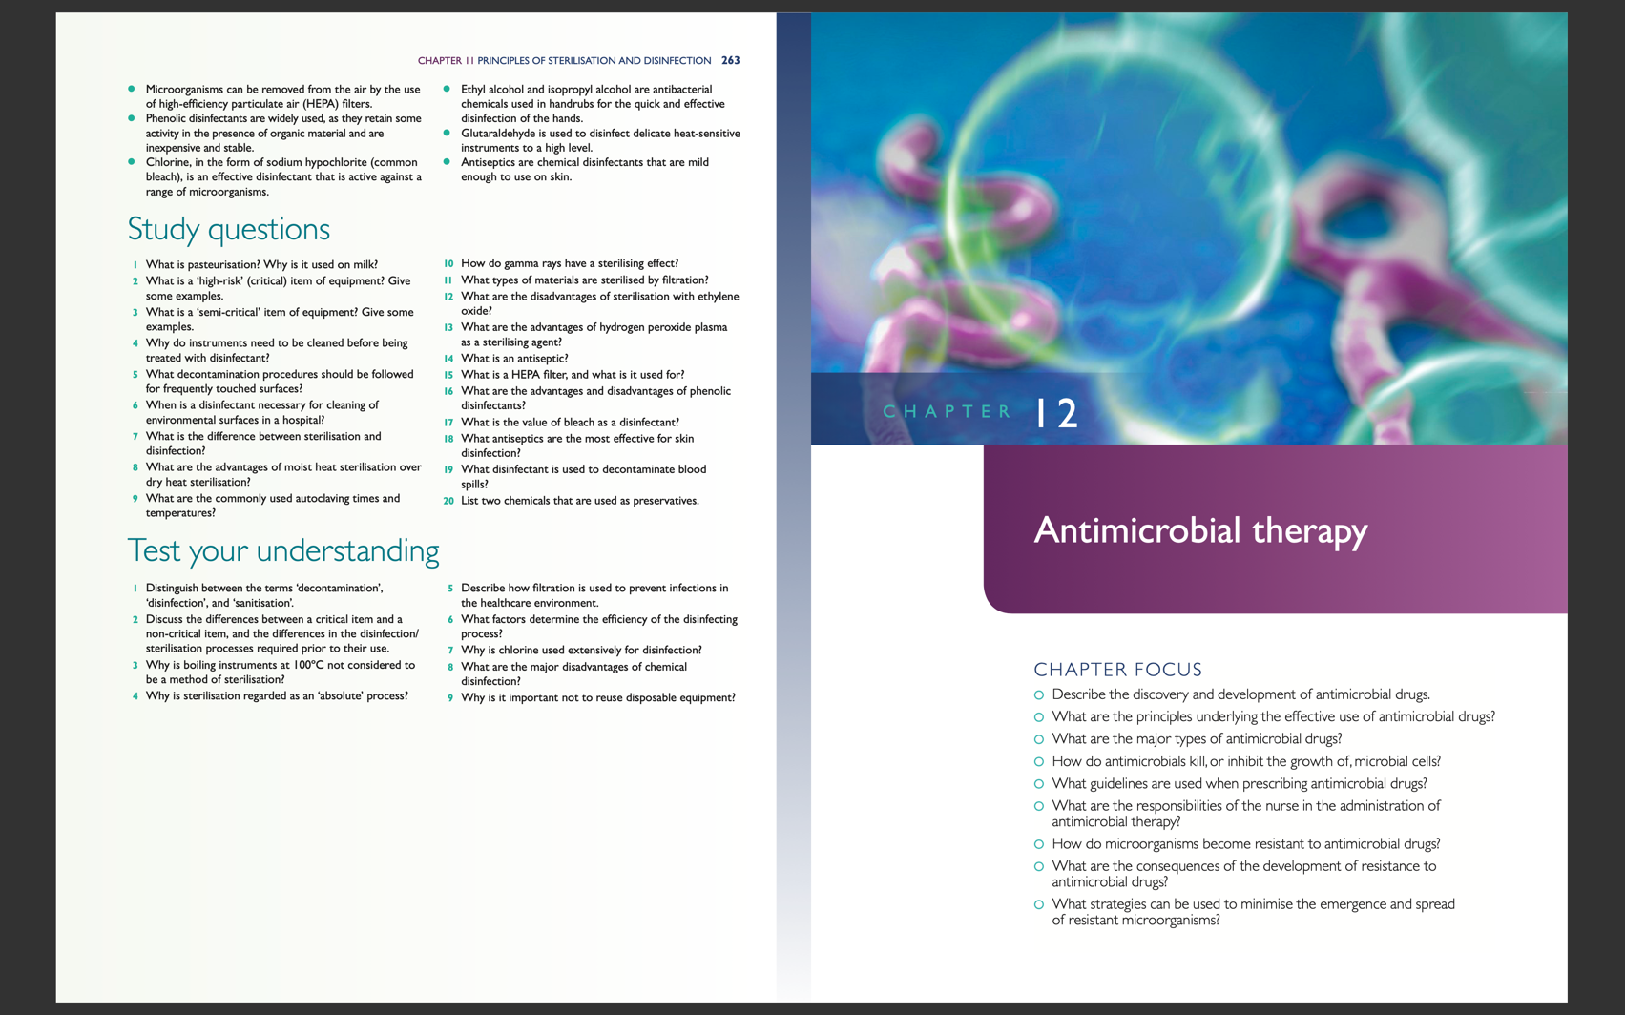
For question 5
